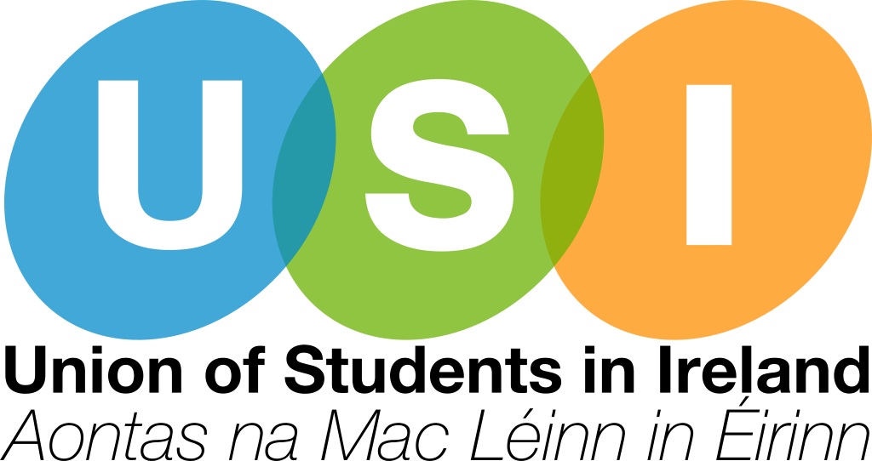
USI Further Education & Training Strategy 2021-2024

About USI

The Union of Students in Ireland (USI) is the sole representative body for third-level students in Ireland and represents 374,000 students in over thirty member colleges across Ireland. Throughout its history, USI has worked relentlessly in the pursuit of student rights in all areas of the student experience.

Overview

USI has long been at the forefront of fostering the role of students and their representatives in shaping their education, supporting the work of local Students’ Unions to develop and expand their capacity and ensuring that they are recognized and support at the institutional and national level.
However, although USI is the only representative body operating within third-level in Ireland, its work is almost wholly concentrated within Higher Education. Currently, USI’s only FE membership comes from the FE colleges in Northern Ireland whom it represents through the Trilateral Agreement. FET Colleges have in the past been members of USI, and in recent years a number of colleges have reached out to USI regarding candidate membership, but this work has not been sustained.
Many of the challenges regarding student and learner representation in the FET sector stem from the vastly different environment which it operates within. Unlike the HE sector, independent Students’ Union structures are not commonly found within the FET sector currently. Some colleges operate student/learner councils but the picture is quite varied across the country and in many cases these structures are supported by a staff member in a voluntary capacity, or as a small part of their role.
Learner voice is currently supported through the National FET Learner Forum which is supported by the National Adult Learning Organisation, AONTAS. This structure meets both regionally and nationally and feedback is provided to both the Further Education & Training Authority, SOLAS and the relevant Education and Training Board. Whilst this structure plays an important role in facilitating feedback at a regional and national level, there is space for learners to play a greater role organisationally.
The appetite for further enhancement of student representation structures within the FET sector have been widely acknowledged by many stakeholders including SOLAS, FET Colleges Ireland and the Department of Further & Higher Education, Research Innovation and Science. The ‘SOLAS Future FET Strategy 2020-2024' acknowledges the need, stating that “more effective means of representation should be developed, ensuring a clear learner voice on organisation oversight, planning provision, delivering support services, curriculum development, quality assurance and improvement, and future strategy”.
With the creation of the first standalone Department for Further & Higher Education comes the opportunity to develop a cohesive tertiary system which supports transitions within and across the tertiary sector. Central to this must be the development of effective student & learner representation structures which support students and learners across the tertiary system to shape their education, and embed representation within their institution’s governance structures.

Strategy Summary

With the exception of ‘FE Engagement in the Northern Ireland, the strategy should be read in chronological order, recognizing that further development and enhancement of student & learner representation within FET can only be facilitated once we have developed and verified the capacity to support it, both within USI and the FET sector.
The strategy is organized into the following sections:
- Building Capacity for Growth – Developing capacity within the FET sector to facilitate the development of autonomous representation structures for students and learners, and developing the organisational capacity within USI to support this.
- FE Engagement in Northern Ireland – Working through our sister organisation NUS-USI to develop USI’s engagement with FE Students’ Unions in Northern Ireland, and facilitate cross-border sharing of knowledge and practice to inform USI’s development work within the Irish FET sector.
- Growing our Membership – Develop resources to support the creation of FET Students’ Unions, and enable them to become USI members, if they so desire.
- Training & Development – Having developed the capacity to enhance USI’s role within the FET sector, create and develop resources to support student/learner representatives and staff supporting these representatives.
- Engagement & Democracy – As USI’s footprint in the FET sector widens, develop approaches to engaging FET students in USI’s democratic structures, recognizing the need to ensure a ‘best fit’ approach in doing so.

Building Capacity for Growth

Key Stakeholders: SOLAS, FET Colleges Ireland, ETBI, AONTAS, Department of Further & Higher Education, Research, Innovation and Science.
As outlined in the Strategy Overview, capacity to support the representation of FET students and learners is quite limited currently, both within the FET sector itself and in terms of resources and structures within USI. The success of this strategy is contingent upon developing a resource that supports students and learners to engage in shaping their education; we anticipate that this can only be achieved when developed in partnership with other key stakeholders.
USI should seek to secure funding that supports the development of autonomous representation structures within the FET sector, and also enables USI to develop its own capacity to support this area of work. Governance and organisational structures within the FET sector differ greatly from the HE sector and it is important to recognize, and address these differences.
Conversations with FET Colleges Ireland and ETBI in particularly over the last few months have indicated an appetite to further develop structures of representation within the FET sector and it is important for USI to take these conversations forward as part of this strategy.
Actions:
- USI will develop more formalized relationships with key stakeholders in the FET sector such as ETBI and SOLAS in order to develop its positioning within, and understanding of the sector.
- Working with key stakeholders, USI will seek funding to facilitate the development of structures of representation within the FET sector including to support FET colleges in establishing these structures, and to enable USI to develop its own capacity to support enhanced representation within the sector.
- Subject to funding, USI will employ staff dedicated to FET Representation & Engagement who will work across the FET sector to develop and expand structures of representation and enhance organisational understanding of FET governance structures.
- USI will work alongside AONTAS to ensure synchronisation with existing learner voice structures such as the National FET Learner Forum is considered as part of the development of new representation structures.
- USI will work with the Department, SOLAS and other key stakeholders to ensure that student representation structures within the FET sector are afforded full autonomy.
- USI will work with ETBI, SOLAS and other relevant stakeholders to ensure systemic representation of students/learners in governance across the entire FET sector.

FE Engagement in Northern Ireland

Key Stakeholders: NUS-USI, FE Students’ Union Officers, FE Students’ Union Staff.

Amongst USI’s 374,000 students, some 140,000 of those come from FE colleges in Northern Ireland. Despite this, USI’s relationship with its FE members in Northern Ireland is quite informal. In line with the established best practice encountered in NUS-USI, USI should investigate emulation of this approach to enhance its’ engagement with FE Students’ Union, recognizing that differing structures call for differing approaches to engagement.

Stronger engagement with our FE membership in Northern Ireland also offers the opportunity for sharing of best practice, recognizing the existence of standalone Students’ Union structures within this sector. In most cases, FE Students’ Unions are supported by one or more full-time staff members who support the election and training of student representatives, most of whom are elected in an unpaid, part-time capacity at the beginning of the academic year (September/October).

Actions:
- Create opportunities for sharing of information and practice with NUS-USI and FE Students’ Unions in Northern Ireland, focusing on Union Organisation & Development, Training and Student/Learner Engagement.
- Engage with and support any training being provided to FE Students’ Unions by NUS-USI and continue to increase our engagement and visibility with FE members.
- Ensure that campaigns and resources are relevant, and available to all NUS-USI members including FE Students’ Unions so far as is possible, working closely with NUS-USI.
- As USI’s capacity and activity in the FET sector increases, look at how relationships between FE members in Northern Ireland and FET members in the Republic of Ireland can be facilitated.

Growing Our Membership

Key Stakeholders: ETBI, FET Colleges Ireland, SOLAS, DFHERIS.
In tandem with the development of USI’s capacity and understanding of the FET sector, and the sector’s capacity to support autonomous student representative structures must come the development of resources to enable these structures to become recognized members of USI.
Actions:
- Develop resources that can support FET colleges to establish autonomous representation structures, such as draft constitutions and election regulations.
- Create Guidance Documentation on becoming a USI member for FET Colleges.
- Develop sample campaign materials and resources that can be used by students/learners running referenda on USI membership within their college.

Training & Development

Key Stakeholders: NUS-USI & NUS UK, ESU, ETBI, SOLAS, FET Colleges Ireland, DFHERIS.
As USI begins to develop its’ capacity to support the FET sector, attention must be turned towards how it can best facilitate student and learner representation within the sector, recognizing that this means going beyond simply repurposing existing training offered to USI’s HE membership. Training & Development should be created and organized in keeping with the needs of the sector. Where relevant, training and capacity building should be offered to staff who support student representation within FET colleges.
Actions:
- Develop training opportunities for FET student/learner representatives, which are adaptable to various roles and institutional structures, and are well researched and evidence based.
- Working with NUS-USI, NUS & ESU, identify good practice approaches to training and development within the Further Education context.
- Develop training & development opportunities that are suitable for rollout to staff supporting student representation within the FET sector.

Engagement & Democracy

Key Stakeholders: NUS-USI & NUS UK, ETBI, SOLAS, FET Colleges Ireland, AONTAS.
As USI’s FET representation increases, it is important that USI’s capacity to engage and support student & learner representatives to effectively advocate for the interests of the students/learners they represent at a local and national level. USI members have access to a range of supports encompassing training, campaign resources, collective representation and ongoing support from Executive Team members throughout the year.
Similar provisions must be made available to FET members, but it is important to recognize the structural and organisational differences that currently exist between FET and HE colleges. Resources and campaigns that are made available to FET members must recognize the specific context within which they operate, and should be developed in partnership with representatives.
Given the differing structures in the FET sector, additional consideration should be given to how best to engage student/learner representatives in USI’s work. Building upon the work that USI has carried out since the COVID-19 pandemic in March 2020, an increase in online activity and engagement may help to lessen barriers for participation by FET representatives.
As representation structures develop, there is a need to review how representatives can engage in existing USI events and campaigns, as well as what new initiatives may need to be created specifically for the FET sector. Financial or practical arrangements may need to be explored with FET Colleges Ireland, ETBs or SOLAS to support FET members in engaging with USI activities. USI expects that this work will progress across the course of this strategy, in line with the development of previous sections.
Action:
- Develop an Engagement Action Plan as USI’s FET membership grows to oversee USI’s work in supporting and engaging its’ FET members (this may come as part of a future iteration of the FET Strategy). This should include, but not be limited to:
  - Campaigns
  - Events
  - Representation on National FET Structures
- As FET membership grows, develop structures and networks within USI to support the engagement of FET members in USI’s democratic structures.
- As FET membership grows, explore the potential for FET representation on the USI Executive Team.
- Work with FET Colleges Ireland, SOLAS or ETBI as relevant to explore financial and practical arrangements to support the full participation of FET members in USI activities.
- Provide support to USI Executive Team members to engage with, and represent the interests of FET students/learners.

Conclusion

This document sets the direction of USI’s work in the FET sector over the next three years. It must be acknowledged that the success of this strategy is contingent upon the availability of funding to support capacity building within the FET sector, and organisationally within USI.
USI recognizes the vast differences between the FET and HE sectors and the need to significantly develop its’ own capacity and understanding of FET structures in order to effectively advocate for the interest of students/learners within this sector. This strategy provides a blueprint for significant transformation of representation structures within the FET sector, and a pathway for enhanced cohesion between FET and HE in years to come.

USI is committed to working with the Department of Further & Higher Education, Research Innovation and Science, with national bodies such as SOLAS, ETBI, FET Colleges Ireland and AONTAS, and with students/learners and staff in the FET sector to develop effective autonomous representation structures for FET students/learners.

SOLAS FET Strategy 2020-2024, Available at < https://www.solas.ie/f/70398/x/64d0718c9e/solas_fet_strategy_web.pdf>
NUS-USI is the student movement in Northern Ireland, a jointly operated enterprise, headquartered in Belfast, between the Union of Students in Ireland and the National Union of Students of the United Kingdom
In USI terms, this is referred to as ‘The NUS-USI Region’

