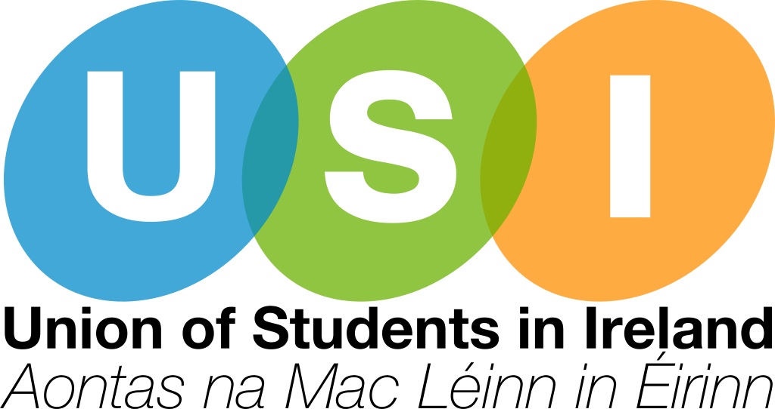

USI Back to Education Allowance Reform Strategy Paper 2021-2024

About USI

The Union of Students in Ireland (USI) is the sole representative body for third-level students in Ireland and represents 374,000 students in over thirty-member colleges across Ireland. Throughout its history, USI has worked relentlessly in the pursuit of student rights in all areas of the student experience.

Overview

As an initiative overseen by the Department of Social Protection, the Back to Education Allowance helps people return to college and is a vital support for many mature students or those returning to college. USI welcomes the commitment to review the BTEA in the Programme for Government. USI believes that the current rates for BTEA are not adequate in meeting the costs of attending Higher Education in Ireland and this needs to be addressed. From 2018 to 2019 there was a 19 per cent decrease in the number of students in receipt of the payment.
The BTEA rate is based on the rate of the qualifying payment the person is in receipt of prior to returning to education. USI is very concerned that this rate does not take any of the additional costs of attending higher education into consideration.
The Vice President for Equality and Citizenship has primary responsibility for issues in relation to the Back to Education Allowance (BTEA) and supported by the Vice President for Welfare.
This Reform Proposal mandates the Vice President for Equality and Citizenship to work with the Department of Social Protection in the review of BTEA and highlight the need for reform of the current system including qualifying criteria, minimum wait period prior to applying for BTEA and BTEA rates.
USI shall lobby the Department of Social Protection for the reform of administration of the Back to Education Allowance on the basis of the following recommendations:
- Qualifying Criteria
- Reassessment Criteria
- Back to Education Allowance Rate
- Sharing of Application Information
- Electronic Filing and Application Process
- BTEA support and guidelines within the Department of Social Protection
- Training and Support for Students’ Unions
- Introduce Indicative Timeframes
- Standardize return to BTEA

Qualifying Criteria
The current qualifying criteria for BTEA is quite strict and acts as a barrier to those returning to education. In order to qualify for the BTEA support, a student must have been getting a qualifying social welfare payment for 9 months (234 paid or credited days of unemployment). This criteria and others can prevent people from returning to education and impact on educational attainment.
USI acknowledges that as a result of COVID-19, the Government announced under the July Jobs Stimulus Package that access to the Back to Education Allowance would be extended to people in receipt of the COVID-19 Pandemic Unemployment Payment (PUP) and the minimum wait period prior to applying for BTEA was waived for recipients of PUP. Continuing with this amendment once the Pandemic Unemployment Payment (PUP) ceases to exist will allow for greater engagement with the BTEA and thus making the process clear and easy to engage and support more students into Further and Higher Education.

Reassessment Criteria
Since the 2016/2017 academic year, students who are in receipt of BTEA and work on a part-time basis over the summer period are required to have their income reassessed. Before this, part-time work during the academic year did not affect the rate of BTEA paid. Students have expressed concern about the varied process that is undertaken to reassess their situation. USI believes this decision should be reversed and allow students engage in part time work without affecting their BTEA allowance.
Investing in BTEA and easing the criteria on entry will have a positive long-term impact on economic growth and social cohesion.

Back to Education Allowance Rate
Currently the payment rate that is in place is not adequate to support those who are receiving the BTEA and the constantly increasing cost of living in Ireland. USI shall lobby the Department of Social Protection to increase this rate of payment to allow for greater support for students returning to education and their families.

Sharing of Application Information
In order to support students applying for the BTEA and other Department of Social Protection supports; the Department of Social Protection, SUSI and other relevant Government Departments should engage in data sharing. Therefore, allowing for cross-referencing of applications to ensure that students are not awarded both the Back to Education Allowance and the SUSI maintenance grant, and subsequently asked to repay one.
At present, although students in receipt of BTEA are not entitled to the maintenance component of the student grant, they must still submit a student grant application form to be assessed for a fee grant to pay their Student Contribution.
Electronic Filing and Application Process
At present applications for BTEA must be through physical means and posted directly to the Dept of Social Protection. Students should also be given the choice of applying for BTEA and submitting appeals electronically. This would ensure that the people reviewing the documentation would receive documentation immediately and would be able to review much more efficiently, and would reduce the complicated paper trail.

BTEA support and guidelines within the Department of Social Protection
Under the review of the Back to Education Allowance, training and support for Department of Social Protection officials must be offered in order to support their work and ensure consistency in advice offered to, and decisions made on BTEA applicants.
The creation of comprehensive, easy to understand guidelines and training to more effectively manage casework for Department of Social Protection officials to more effectively manage casework would also sure there is consistency in advice and decisions for BTEA applicants.

Training and Support for Students’ Unions
Training for Students’ Unions:
Training should be provided to Students’ Unions to ensure that they are equipped with the skills and knowledge to support students with queries and issues relating to their BTEA application.
Establishment of a support line:
USI should lobby for the creation of a support line for Students’ Unions similar to the equivalent service currently offered by SUSI. This support line would allow Students’ Unions to represent and advocate on behalf of their members.

Introduce Indicative Timeframes
USI shall liaise with the Department of Social Protection to introduce indicative timeframes for the following:
- Review of applications and response;
- Response to queries from applications and their representatives;
- Completion of appeals process.
The introduction of these indicative timeframes will allow applicants to manage their expectations and plan accordingly.
Standardize return to BTEA
USI shall lobby the Department of Social Protection to amend the requirement that recipients of BTEA who switch to illness benefits must remain on the new payment for twelve months before they are eligible to revert to BTEA.

Conclusion
This document sets the direction of USI’s lobbying work in regard to the Back to Education Allowance over the next three years and during the review of the BTEA as outlined as a commitment in the Programme for Government.

Written answer from Minister for Employment Affairs and Social Protection on Back to Education Allowance, Thursday, 26 September 2019
Government of Ireland, Programme for Government – Our Shared Future, 2020, page 98.

