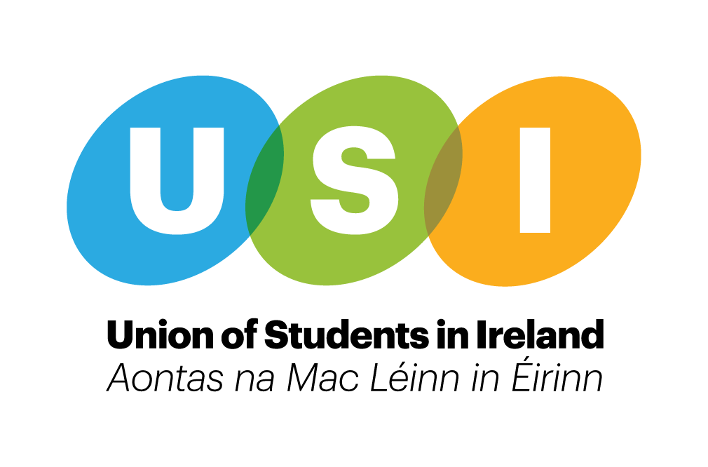

Union of Students in Ireland Climate Action Policy
February 2020

Introduction
The Union of Students in Ireland (USI) is the representative body of 374,000 students across the island of Ireland, and is an entirely student-led organisation. We are comprised of further and higher education member students’ unions across the island, both North and South, and seek to protect and enhance education, the rights of students, and the ability of all to access third-level education.

In the midst of a climate emergency, Ireland as a country has been slow to react to improving our performance in addressing climate change. While the Government has started to introduce measures such as increasing carbon taxes and incentives for improving sustainable practices, we have already seen significant changes to the country we live in, such as rising sea levels, a loss of biodiversity, increased flooding, and water shortages in the summer to name a few.

It should be highlighted that much of the onus of tackling the Climate Emergency has been placed on individuals and encouraging them to change their day to day behaviour and consumer habits. However, USI strongly believes that in order to properly tackle Climate Change we need to ensure that students and young people are not carrying the entire burden of the adjustments needed to address the Climate Crisis. A complete overhaul of the economic systems which allows and perpetuates the current damage being done to our planet is essential if we are to be serious about addressing this crisis. The Government needs to take responsibility for Climate Action and move toward a more circular and sustainable economic model.

However, as the national student movement, USI and its members are in a very unique position to be part of working towards a more ‘green’ country. Through working collaboratively with other climate action groups, lobbying for more funding for specific sustainable practices across our higher education institutions (HEIs) and calling for sustainability and climate education to be incorporated into existing curriculums, students can be part of the driving force in ensuring that our Government acts fast on these pressing issues.

This climate action policy will outline various aspects of climate issues and the position of the Union of Students in Ireland in relation to those highlighted. It will form the basis of all our lobbying efforts in the future and we will continue to lobby and campaign to ensure that goal is achieved.

Written and prepared by: USI Executive Team.
Contributors and special thanks: USI Climate Action Working Group and Member Organisations during consultation periods.
Contents

- Sustainable Development Goals
- Just Transition
- Education
- Workers’ Rights
- Fairtrade
- Carbon Tax
- Energy
- Reducing Energy Consumption
- Ethical Fund Management
- Divestment of fossil fuel
- Public Transport
- Deposit and Return Schemes
- Food
- Waste Management
- Climate Refugees
- Partners and Collaborators

Sustainable Development Goals
The Sustainable Development Goals (SDGs) are the blueprint to achieve a better and more sustainable future for all. They address the global challenges we face, including those related to poverty, inequality, climate change, environmental degradation, peace and justice. The 17 Goals are all interconnected, and in order to leave no one behind, it is important that we achieve them all by 2030. On Wednesday 18th September 2019, USI were named as one of 12 Sustainable Development Goal Champions of the following SDGs,

3: Good Health and Well-Being
4: Quality Education
5: Gender Equality
7: Affordable and Clean Energy
10: Reduced Inequalities

USI Position:
- To SDG-proof USI campaigns, policies, and other relevant areas of their work. This should involve, but is not limited to, linking our campaigns to the SDG goals, including SDG information in our social media channels (especially during campaign weeks), and working with external bodies to align our work more in line with these goals.
- To inform members of what they can do to bring these Goals into their day to day lives.

Just Transition
Just Transition is a concept developed by the trade union movement that includes a range of safety nets needed to secure workers' rights and livelihoods when countries’ economies are working towards more sustainable production, primarily to address the climate emergency and to protect biodiversity. It is interwoven into most of this policy in many different ways.

It is based on workers, their unions, employers, government and communities discussing and working together (social dialogue) to achieve this. A plan for Just Transition will seek to provide decent jobs, social protection, more training opportunities and greater security for all workers and communities affected by climate change policies and the transition to a low-carbon economy.

A ‘Just Transition’ to a post-carbon economy - one that responds to the crisis of job insecurities is vital for students and recent graduates, as citizens. Moving away from fossil fuel-dependent industries may create slack in that labour market. Students and workers need to become resilient to shifting industry practices through appropriate up-skilling, re-skilling, and education.

Education
Education is one of the most powerful tools you can use to transform the world around you. It is therefore imperative that sustainability is embedded within the curriculum, from primary through to third-level education. By empowering our student community to embrace sustainability, and teaching them how to incorporate it into their field of study, we can ensure that they continue to lead the local, national and global transformation towards a more sustainable society.

There are also crossovers between education and a Just Transition. Two of the International Labour Organisation (ILO) Just Transition Outcomes are ‘Assessing employment, social and economic impacts of ecological transition and green jobs potential’ and ‘Implementing skills development and upgrading measures to enable transitions in labour markets, and low-carbon and more resource-efficient enterprise development and green job creation’, much of which would be considered during the development and amendment of curriculum.

USI Position:
- USI to lobby the Department of Education and Skills to broaden its' Education for Sustainable Development Advisory Group to ensure students are represented on this group going forward.
- USI should ensure that all current and future dialogue with the NCCA on Junior and Senior Cycle reform emphasise the need for sustainability to be embedded within the secondary level curriculum.
- USI to work with the Department, and key bodies such as the Higher Education Authority to scope out current practice in embedding sustainability within the curriculum, and to promote this across the sector.
- USI to work with the National Forum for the Enhancement of Teaching & Learning to develop resources and open conversations on the embedding of sustainability within the curriculum through a teaching & learning lens.
- USI to lobby for Higher Education Institutions, in collaboration with other relevant stakeholders, to map out where education paths may lead into issues with industry who will be going through a period of Just Transition and adjust their curriculum to suit. This should be inclusive of research students who may be carrying out research that is funded by an industry going through a period of Just Transition.
- USI to advocate for funding to be made available for research into sustainability in various forms.

Workers’ Rights
USI recognise that workers’ rights are students rights and many students work to get themselves into education, keep themselves there and are future workers as graduates. An understanding of workers’ rights is key to understanding of a just transition.
A proper Just Transition must ensure that any new jobs that have been created must retain the wages, pensions and conditions before the transition. USI will not stand for a transition to low paid, precarious work. For a Just Transition to be a reality, we must ensure there is adequate funding provided by the Government and that the approach to industrial disputes is not voluntarist, as currently the recommendations from industrial resolutions through current mechanisms do not have to be taken up by law and instead leave it in the discretion of the employers as to if they want to implement the recommendations.
USI Position:
- USI to support Trade Unions in their lobby for sufficient Government funding for a Just Transition.
- USI to lobby for the removal of the approach to industrial relations procedures to be voluntarist.
- USI to work with the Just Transition Alliance (JTA) comprised of the Irish Congress of Trade Unions, Friends of the Earth, SIPTU, FORSA and the Stop Climate Chaos Coalition and make representations where possible.
Fairtrade
Fairtrade is about better prices, decent working conditions, local sustainability, and fair terms of trade for farmers and workers in the developing world. By ensuring that fairtrade items are used at USI events, it improves the financial positions of these workers by allowing them to get a better deal for their produce and enables them to have more control over their lives.

USI Position:
- USI events exclusively use products recognised as ‘Fairtrade’ where practicable.
- USI to support the work of MOs in becoming Fairtrade campuses.

Carbon Tax
Carbon tax is a charge applied to carbon-emitting fuels such as coal, peat, oil and natural gas. Large companies such as Ryanair and Apple Green have not released their carbon emission figures in the past which means that we do not know how much pollution these companies are contributing to the climate crisis, making it impossible to hold them to account for all the carbon they are releasing into our air. To meet Ireland’s emissions target, the government set out in their new Climate Action Plan that they plan to quadruple the current carbon tax that we pay from €20 to €80 per tonne by 2030, however, the government has provided no details as to how this will be phased out. In Budget 2020, we saw an increase of carbon tax to €26 per tonne.

An overall increase in carbon tax would disproportionately hurt many students and members from low socioeconomic backgrounds by placing them under further financial pressure and stress due to the living conditions they endure that they somewhat have no control over. That the carbon tax should be measured on a scale of those who release the most emissions - large corporations.

The fight against climate change in this climate emergency can only win if students and ordinary workers are part of it. Another one of the International Labour Organisation (ILO) Just Transition Outcomes is ‘Designing innovative social protection policies to protect workers and vulnerable groups in the context of more ambitious climate adaptation and mitigation strategies.’ Students are one of these vulnerable groups and should be considered in the drafting of policies in this area. For example, imposing unfair carbon taxes is a hindrance to students in a Just Transition.

USI Position:

USI to work in partnership with appropriate campaign groups to actively lobby the government on ensuring that larger corporations disclose their carbon emission figures each year.

USI to directly lobby the government to develop a solution to alleviate the individual financial pressure on students and those from lower socio economic backgrounds due to carbon tax.
- Students to be considered in the drafting of social protection policies.

Energy
At the moment, the need for Higher Education Institutions (HEI’s) to use renewable energy is not a requirement in procurement contracts. There are a number of different types of renewable energy such as solar and wind energy that some HEI’s have chosen to investigate and invest in but the Government should be encouraging the use of renewable energy across our HEI’s. Many HEI’s have published Corporate Responsibility Statements available online which outline their commitment to integrating their social and environmental responsibilities into their mainstream operations, and decisions are made with reference to wider sustainability issues.

USI Position:
- USI to lobby Government to ensure additional points are allocated through the official procurement process to energy providers who supply renewable energy.
- USI to lobby the Government to ensure that they future proof all plans for future builds and plan on developing sustainable infrastructure.
- USI to lobby Government to provide funding for HEI’s to invest in the development of clean energy technologies on campuses.

Reducing energy consumption
When you consume less power, you reduce the amount of toxic fumes released by power plants as most of our energy is generated by burning fossil fuels, it also helps to conserve the earth’s natural resources and protect ecosystems from destruction.
There are many benefits to reducing energy consumption for students such as reducing the cost of bills and having less impact on the environment.

USI Position:
- Advocate to members and students to adopt energy saving habits
- Lobby Government to build energy efficient PBSA
- To prioritise the use of low carbon energy sources and effectively utilise efficient products and services by using high energy rating appliances where possible in private and public housing, buildings and organisations.

Ethical fund management
As far back as 2010, a UK Sustainable Investment Forum media roundtable heard that 49 per cent of investors want to make money and make a difference, while a recent study by the European Social Forum found that sustainable investment now makes up 11 per cent of the portfolios of high net-worth individuals.
Some organisations choose to invest in funds that exclude ‘sin stocks’ that make money from alcohol, tobacco, fossil fuels and so on. Others choose to invest in funds that improve the environmental, social and governance (ESG) policies of organisations that have a positive impact on society.
USI Position:
- USI condemns any investment in funds that support non-ESG ethical policies/organisations.
Divestment of fossil fuel
Another of the International Labour Organisation (ILO) Just Transition Outcomes is ‘Increasing the transfer of technology and knowledge to developing countries, as well as innovation and responsible investment by both public and private entities that can stimulate economic transformation, sustainable and inclusive growth, and green job creation, including rallying the private sector and actors in the investment and finance community’. This outcome is applicable to higher education institutions where divesting from investment in fossil fuel infrastructure is vital.
USI Position:
- USI will work with and support any divestment campaigns taking place across our membership.
Public Transport
In order to shift our over reliance on private and individual modes of transport, government investment needs to shift from the construction of roads and into public transport. We need to exponentially expand our bus fleets in urban areas, build high speed rail and metro tracks across the island and divert funding from road projects into public transport infrastructure. Public Transport should be a public good, there to serve the needs of society and the economy on a round the clock basis.

USI Position:
- A new long term investment plan that diverts infrastructure funding from roads to public transport.
- Expansion of bus services in rural and urban areas to end the reliance on cars in commuter belts and rural areas.
- Expansion of and connection of urban transport modes such as DART, LUAS and BUS systems.
- Expansion of night-time public transport options to decrease the need for taxis especially in high congestion areas where there is regular demand for night-time transport.
- Expansion of rail system in Ireland to connect rural areas to urban areas.
- Provision of free public transport to all students, OAPs, those under 18 and those with a disability.
- Provision of low-fare transport to incentivise use away from private transport.

Deposit Return Scheme
A deposit and returns scheme is a system where there is a small amount of money put on cans, glass and plastic bottles or coffee cups, or any item deemed appropriate. When the item is returned, the deposit is then returned to the person who returned the item. For example, a 10 or 20 cent charge would be added onto all coffee cups. Once the coffee cup is cleaned and returned to the returning machine or station, the money will be given back to the customer. This adds incentives for people to return their reusable items to be recycled. This has been seen to work very successfully in other EU countries such as Berlin, Denmark, Netherlands and Scotland.
USI Position:
- USI to lobby the department of education and skills and other appropriate departments of the Dáil to introduce this scheme both nationally and into the higher education sector.
- USI to lobby HEI’s to introduce a deposit return scheme in their on-campus shops, cafes and restaurants on all glass and plastic bottles, coffee cups and cans.
Food
Presently, large amounts of food being produced is not consumed and results in a large amount of food waste and we must become more conscious of our food consumption, waste management and the disposal of food packaging. Food banks involve shops who have surplus in date produce donating this food to charity groups, this supports those who otherwise may have not been able to afford to buy this food. Consuming local produce and shopping locally will not only support local food and retail businesses but will also reduce the carbon distance and impact of food and often includes buying in season food grown locally. Zero waste shops are shops in which food can be bought without plastic packaging or you can bring your own container and refill on household products and food. The idea of these shops is to reduce our plastic consumption and aim to have no food packaging waste.
USI Position:
- USI to support Member Organisations in developing links with food banks.
- USI to support shop local campaigns and lobby HEIs to support local producers within College canteens and shops.
- USI to lobby for the reduction of single use food packaging on campuses.
- USI to lobby HEI’s to introduce zero waste facilities in their campus shops.
- USI to produce list of companies that ensure that any procurement of goods or services, will be environmentally, sustainably & ethically sourced
- To support Member Organisations in their efforts to ensure there are sufficient vegetarian and vegan options available on campuses.
Waste Management
According to the Environmental Protection Agency (EPA), people living in Ireland produce over 15 million tonnes of waste every year. We do this in our homes, our places of work and leisure. We need to change the way we approach production and consumption and work towards a more sustainable system. There needs to be more focus on how we can reduce, reuse and recycle our waste.
USI Position:
- USI to minimise the environmental impacts of our campaigns by carrying out a sustainable audit before and after each event.
- USI to create a waste disposal policy is created for materials and campaign related activities.
- USI to develop a procedure where members request the amount of material they need (subject to funding conditions) to minimise waste.
- USI to develop a ‘Sustainable Practices Guide to Waste’ to share with MOs.
- USI to create a campaign package that will incorporate plastic free and plastic reduction strategies and mechanisms which MO's can avail of, where they wish to support this campaign within their own HEI.
- USI to support MO’s in their lobbying efforts to their HEI’s to becoming Zero waste campuses.
- USI to lobby the Department of Communications, Climate Action and the Environment to ban single-use plastic and coffee cups in third-level institutions.
- Lobby for the implementation of water filling stations to be placed all across campuses and around student accommodation complexes.
Climate refugees:
The impacts of climate change can be devastating on communities. Drinking water is likely to become even scarcer in many parts of the world. Crops and livestock struggle to survive in climate change ‘hotspots’ where conditions become too hot and dry, or too cold and wet, threatening livelihoods and exacerbating food insecurity.

Flooding, drought, and other natural disasters force people out of their homes, meaning they become refugees.

USI has clear policies to end Direct Provision, and to support refugees and asylum seekers through access to Higher Education. It is clear that the number of people seeking asylum due to climate disaster will rise in the years to come. To that effect, we believe the state needs to be ready to accept more refugees in the coming years, to deal with the fallout of climate .

It is worth noting also, that communities of colour and working class communities are often the most affected, and the least supported. We must recognise the global inequalities at play when it comes to climate action.

USI Position:
- That the state should be ready to accept more refugees due to climate emergency, and that these people will be accepted into a humane and dignified system.

Partners & Collaborators
It is important that the fight against climate change is not perceived to be the responsibility of any one person, organisation, community, or country alone. Change happens when partners and collaborators come together to influence policy, encourage climate action, and help to create a more sustainable model for economic change. USI believes that in order to realise its potential and achieve its goals it must work with other organisations who share the same values. Partnerships such as Stop Climate Chaos, the Ideas Collective (STAND), Fairtrade Ireland, Friends of the Earth, Climate Action & Environment, and Green Campus provide platforms for shared commitment to tackling the climate emergency. These partnerships ensure that USI events and campaigns are more sustainable and eco-conscious. Campaigns such as the 21 Day Challenge, a collaborative project with SSE Airtricity (an Irish Energy Company), which was an extension of the SAVES2 Programme, encouraged students to save energy, reduce fuel use and be more eco-aware through daily challenges.

USI Position:

USI to continue working in partnership with existing groups and collaborators, actively lobbying the government together on shared political asks
- USI to widen it’s partnerships and continue to grow relationships with active collaborators who are encouraging climate action

USI to lobby any companies and organisations that Member Organisations or the USI Executive identify or work with nationally to be more sustainable in their engagement with students.
- Secure agreements with all partners that the projects and events are achieved through the most sustainable methods possible. Also that collective events that provide refreshments are all sourced sustainably ie; Fairtrade.

